

**CAPSTONE PROJECT REPORT**

**Report 1 – Project Introduction**

– Hanoi, September 2025 –

**Table of Contents**

**I. Record of Changes 3**

**II. Project Introduction 4**

1. Overview 4

1.1 Project Information 4

1.2 Project Team 4

2. Product Background 4

3. Existing Systems 5

3.1 KidsOnline 5

3.2 Sc.Edu 6

3.3 PMS preschool management software 7

3.4 SanAn Kids 9

4. Business Opportunity 10

5. Software Product Vision 10

6. Project Scope & Limitations 11

6.1 Major Features 11

6.2 Limitations & Exclusions 15

# I. Record of Changes

| **Date** | **A* M, D** | **In charge** | **Change Description** |
| --- | --- | --- | --- |
| 18/09/2025 | A | Vintkhe176898 | Create project introduction : Overview (project information, project team), Product background, business opportunity, Software product vision |
| 21/09/2025 | A | Vintkhe176898 | Create existing systems, limitation and exclusions |
| 21/09/2025 | M | Vintkhe176898 | Edit software product vision, business opportunity |
| 22/09/2025 | A | Vintkhe176898 | Add major features |
|  |  |  |  |
|  |  |  |  |
|  |  |  |  |
|  |  |  |  |
|  |  |  |  |
|  |  |  |  |
|  |  |  |  |
|  |  |  |  |
|  |  |  |  |

*A - Added M - Modified D - Deleted

# II. Project Introduction

## 1. Overview

### 1.1 Project Information

* Project name: Blue Dolphin Preschool Management System
* Project code: PMS
* Group name: SEP490_G160
* Software type: Web

### 1.2 Project Team

| **Full Name** | **Role** | **Email** | **Mobile** |
| --- | --- | --- | --- |
| Nguyen Quang Hung | Lecturer | HungNQ40@fe.edu.vn | 0912656836 |
| Bui Trung Hieu | Leader | hieubthe173123@fpt.edu.vn | 0913339709 |
| Trinh Pham Doan Trang | Member | trangtpdhe172319@fpt.edu.vn | 0868387111 |
| Pham Duy Kien | Member | kienpdhe170155@fpt.edu.vn | 0867281968 |
| Dau Dinh Hieu | Member | hieuddhe176719@fpt.edu.vn | 0328637209 |
| Nguyen Thi Khanh Vi | Member | vintkhe176898@fpt.edu.vn | 0377305466 |

## 2. Product Background

During the operation of Blue Dolphin Kindergarten, the board of directors and related departments (teachers, accountants, facilities managers, nutritionists, as well as parents) are facing many difficulties in managing and coordinating information. Currently, tasks such as classroom management, curriculum, timetables, attendance, nutrition menus, financial receipts and expenditures, and communication with parents are mainly done manually or through many separate channels such as documents, spreadsheets, or chat groups. This leads to duplication of work, data errors, difficulties in monitoring, and lack of transparency in sharing information between the school and parents.

Teachers have to spend a lot of time on administrative tasks such as recording attendance, comments, and managing teaching schedules, instead of focusing on care and teaching. The accounting department spends a lot of effort in managing tuition fees, cash books, creating receipts/payments, and financial reports. It is difficult for the nutrition and facilities department to monitor menus, place orders, manage assets and classrooms centrally. Meanwhile, parents want to be able to easily monitor their children's schedules, menus, personal information, pay tuition online and update photos of their children's activities transparently and quickly.

Faced with these shortcomings, the Board of Directors of Blue Dolphin Kindergarten proposed to build the Blue Dolphin Preschool Management System - a centralized and comprehensive digital management system. This system was formed from the practical needs of the school's departments combined with the wishes of parents, aiming to:

* Reduce administrative work for teachers and staff.
* Standardize and digitize the process of managing students, finances, nutrition and facilities.
* Improve the effectiveness of coordination between schools - teachers - parents.
* Increase transparency, accuracy and timeliness in information, contributing to improving the quality of education and childcare services.

## 3. Existing Systems

### 3.1 KidsOnline

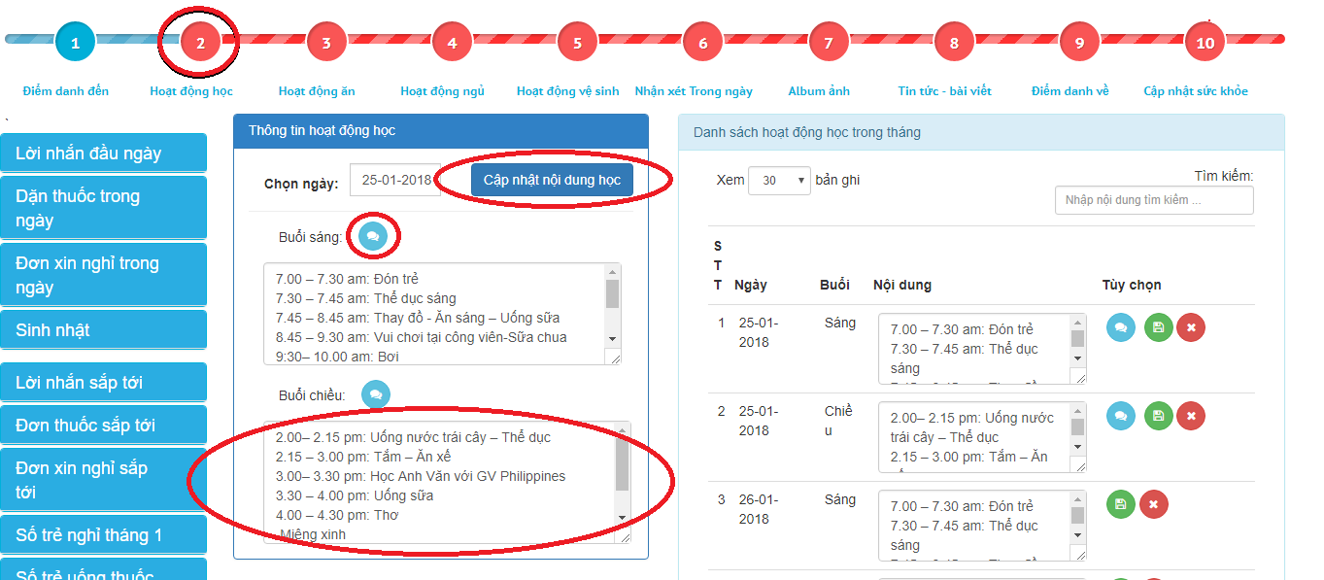

Figure 1.1. KidsOnline (Link : https://kidsonline.edu.vn/en/)

KidsOnline software first appeared in 2016, and has now become a solution for customer care, attracting enrollment and managing activities in kindergartens that many people choose. This tool creates a platform that connects all members of the school, from management, staff, teachers, kitchen staff, medical staff to parents. The system is highly rated 4.7/5 thanks to its ability to automate and optimize many daily management tasks.

Outstanding features:

* Student information storage and automatic attendance
* Children's progress reporting system
* Multi-channel communication with parents
* Menu updates and health monitoring
* Detailed financial reports

Advantages:

* Automate many daily operations
* Parents can track their children's learning process, menu and health
* Supports both computers and mobile phones

Differences with Blue Dolphin Preschool Management System :

| **KidsOnline** | **Blue Dolphin Preschool Management System** |
| --- | --- |
| * Support menu updates and health tracking. * Mainly supports learning progress reports, menu updates, health and student information. | * In addition to menu management, there are detailed nutrition reports, supplier management. * In addition to storing student information and progress reports, there is also management of curriculum framework, timetables, classes, school year, teaching schedules, and extracurricular organizations. |

Table 1.1. Differences between KidsOnline and Blue Dolphin Preschool Management System

### 3.2 Sc.Edu

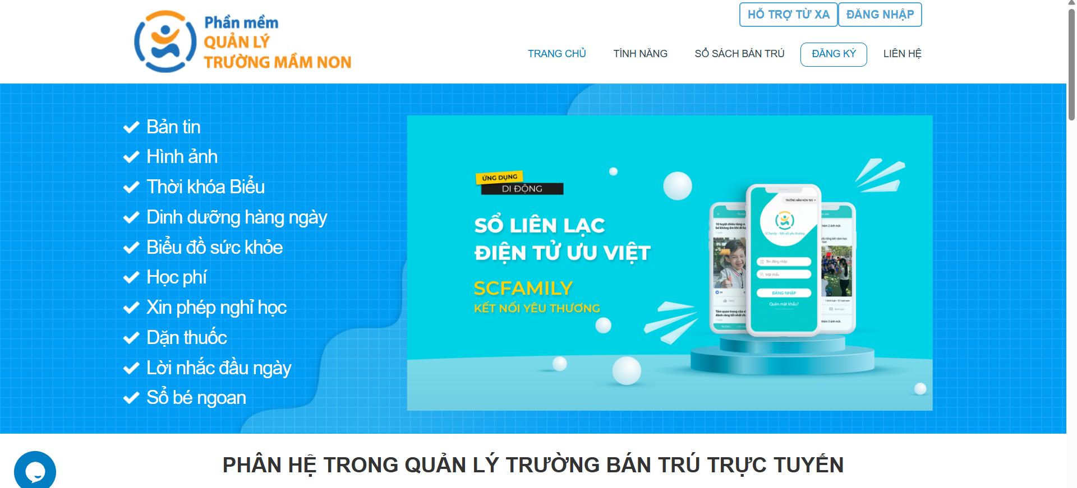

Figure 1.2. Sc.Edu (Link : https://www.sc.edu.vn/)

SC.Edu is a software for managing boarding kindergartens operating on an online platform, integrated with many smart features, suitable for educational institutions looking for a modern tool to improve management efficiency. The system supports use on both computers and mobile devices, only needing an Internet connection to access and operate anytime, anywhere.

Outstanding features of SC.Edu:

* Manage students' presence or absence, regularly monitor students' health through vaccination, weighing, etc.
* Manage nutritional rations: Help calculate and balance nutritional rations for students every day, ensuring accuracy and science.
* Manage income and expenditure: Through the software, you can quickly create income and expenditure vouchers in the class, and at the same time flexibly support tracking income and expenditure activities of each class and the whole school.
* Message: The school can send text messages to parents and teachers through the software.
* Calculate teacher salaries: SC.Edu software supports information storage, attendance and salary calculation for all staff.
* Pay tuition fees online: SC.Edu provides users with a convenient, fast and safe online tuition payment channel with a variety of different forms.

Differences with Blue Dolphin Preschool Management System :

| **Sc.Edu** | **Blue Dolphin Preschool Management System** |
| --- | --- |
| * Mainly focuses on managing attendance, health, income and expenses, and nutrition. Few in-depth features for learning management. | * Manage curriculum framework, timetables, classes, teachers, teaching schedules, extracurricular activities, student records. In addition, manage assets, facilities |

Table 1.2. Differences between Sc.Edu and Blue Dolphin Preschool Management System

### 3.3 PMS preschool management software

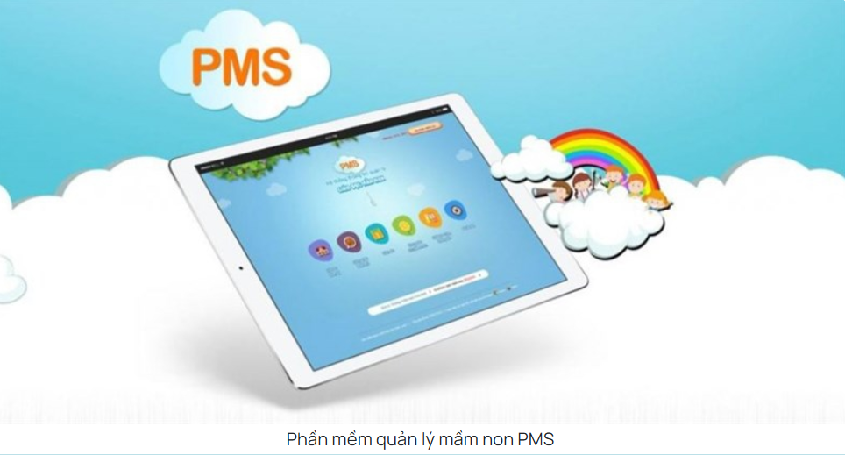

Figure 1.3. PMS (Link : https://qlmn.vn/)

PMS preschool management software supports calculating the quantity of ingredients and nutritional components for young children at school. Through this solution, teachers will save time balancing the menu for children as well as taking daily attendance. In addition, thanks to the smart statistical reporting feature, schools can report the situation to the Department, Department, and Ministry of Education in the fastest way.

Outstanding features of PMS software:

* Calculate nutritional values ​​of food portions quickly, accurately, and scientifically.
* Support daily student attendance, saving time.
* Help flexible statistical reporting.
* Through the software, Department leaders can proactively grasp the situation of raising young children at schools.

Differences with Blue Dolphin Preschool Management System :

| **PMS preschool management software** | **Blue Dolphin Preschool Management System** |
| --- | --- |
| * Specializes in calculating nutritional values of meals and balancing children’s menus with scientific accuracy. * PMS systems focus primarily on nutrition, diet, and reporting. | * Includes nutrition reports, menu management, supplier management, and detailed student health records, offering both dietary monitoring and resource management, making it more comprehensive. * The Blue Dolphin system is designed with a more comprehensive orientation, not only managing nutrition but also strongly expanding into learning management, teaching schedules, extracurricular activities, curriculum framework, school year management, parent connection and overview reports. This helps schools not only operate effectively but also monitor and develop children comprehensively in terms of nutrition, learning and activities. |

Table 1.3. Differences between PMS preschool management software and Blue Dolphin Preschool Management System

### 3.4 SanAn Kids

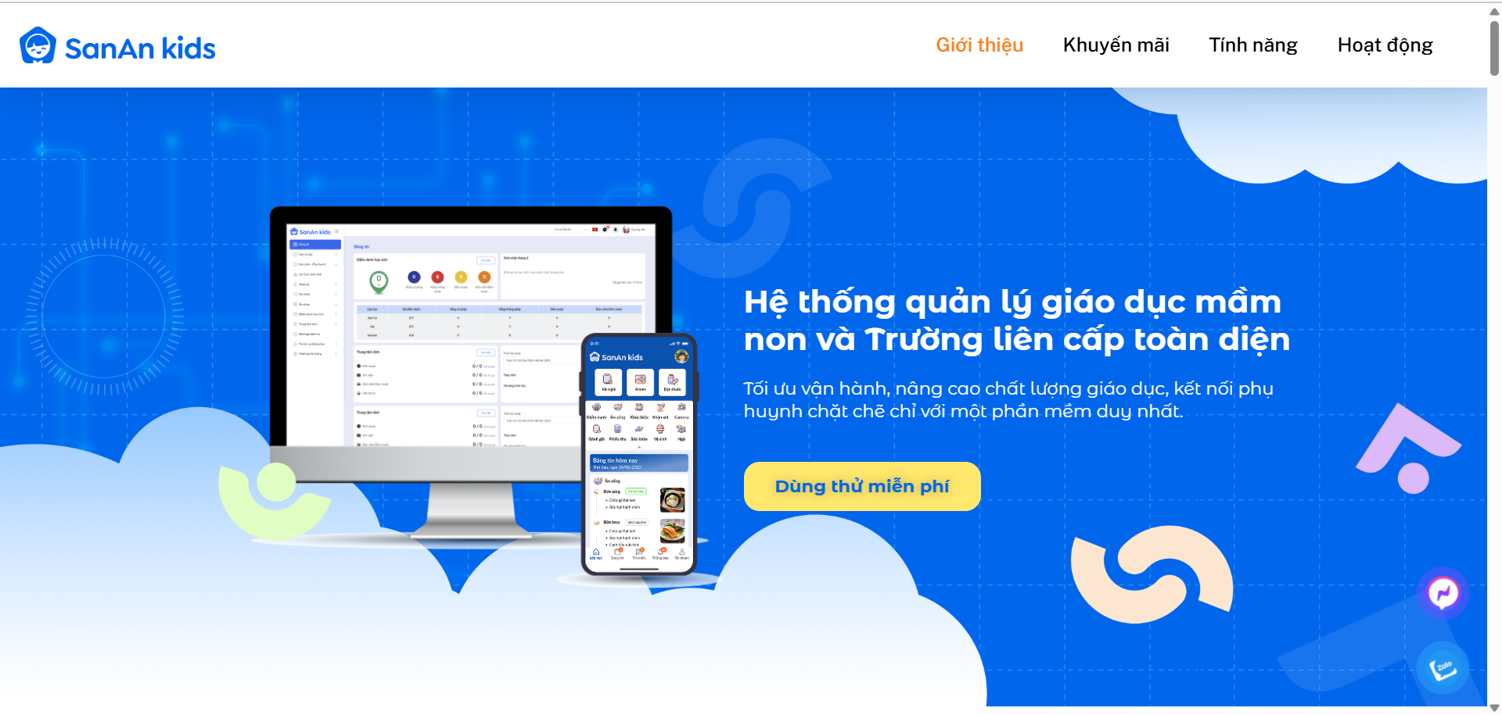

Figure 1.4. SanAn Kids (Link : https://sanankids.edu.vn/)

SanAn Kids supports the management and operation of preschools, effectively connecting schools and parents. With features such as attendance, activity updates, health and learning reports, tuition management, etc., SanAn Kids provides a comprehensive, easy-to-use preschool management software solution that saves time and improves the quality of child care and education.

More than 200 kindergartens nationwide and 600 kindergartens in Japan trust

Advantages of Sanan Kids preschool education management software :

* Comprehensive multi-location management: Monitor, operate and synchronize data between branches – anytime, anywhere.
* Integrate everything on one platform: From attendance, tuition, reporting to parent communication – all in one single app.
* Instant updates on baby's photos, activities, and status – increasing connection and trust.
* AI Integration: Automate processes, optimize work – Operate “smarter”.

Differences with Blue Dolphin Preschool Management System :

| **SanAn Kids** | **Blue Dolphin Preschool Management System** |
| --- | --- |
| * Does not emphasize facility and asset management. | * Provides classroom management and asset management modules, helping schools optimize infrastructure and resources. |

Table 1.3. Differences between SanAn Kids and Blue Dolphin Preschool Management System

## 4. Business Opportunity

1. Needs

Many kindergartens are currently managed manually (books, Excel), making it difficult to take attendance, monitor health - nutrition, manage tuition, finances and exchange information with parents. This leads to errors, wastes a lot of time and lacks transparency. Therefore, the urgent need is a centralized, modern and friendly management system.

2. Solution

Building a semi-boarding kindergarten management software that fully integrates the following features: managing students, teachers, parents, classes, admission, timetables, extracurricular activities, automatic attendance, health records, tuition management, cash books, menus, nutrition, assets and financial reports. At the same time, providing a multi-way communication channel between the school - teachers - parents.

3. Business model

Applying the SaaS (Software as a Service) model, deploying online on both computers and mobile devices. Schools only need to register an account, no need to invest in complex infrastructure. The system is supported with installation, user instructions, maintenance and regular upgrades to ensure operational efficiency.

4. Profit model

Revenue comes from periodic usage fees (monthly or annually), calculated according to school size or number of students. In addition, the system can expand value-added service packages such as: in-depth analysis reports, extended storage capacity and priority customer support services.

## 5. Software Product Vision

In the first year, the system aims to reach at least 1,000 regular users.

The platform will fully deploy core functions such as: student, teacher, parent, class management, admission, timetable, curriculum, extracurricular, attendance, tuition, cash book, menu and nutrition.

The system helps reduce administrative work for teachers, focusing more on teaching and childcare. School administrators can use dashboards, learning reports, financial reports, nutrition reports and analysis tools to make accurate strategic decisions.

Parents can track their children's information (class schedule, menu, health, assessment results), pay tuition online, view activity albums and receive information from the bulletin board.

In the long term, the system will continue to be expanded and upgraded, optimizing existing features such as asset management, payroll, timekeeping and suppliers; At the same time, it adds advanced data analysis tools and integrates smart support services to build an increasingly comprehensive management platform.

The ultimate vision is to become a comprehensive digital solution for boarding kindergartens, modern, transparent and user-friendly, contributing to improving the quality of education, nutrition and the connection between schools - teachers - parents.

## 6. Project Scope & Limitations

### 6.1 Major Features

| Type of User | Description |
| --- | --- |
| Admin | Responsible for overall system management, including creating and managing user accounts, assigning roles, setting permissions, monitoring system activities, and ensuring smooth operation of the platform.Responsible for overall system management, including creating and managing user accounts, assigning roles, setting permissions, monitoring system activities, and ensuring smooth operation of the platform. |
| Teacher | Classroom and student management: attendance, tracking learning and playing progress, daily comments, communication with parents. |
| Parent | Track your child's information: attendance, school announcements, class schedules, nutritional menus, health status, tuition fees, and communicate directly with teachers/schools. |
| Accountant | Financial management: revenue - expenditure, tuition, receipt/payment voucher creation, cash book management, financial reporting to the board of directors. |
| Administrative staff | Manage administrative and facilities operations: menu management and nutrition reporting, supplier booking and management, classroom and asset management. |

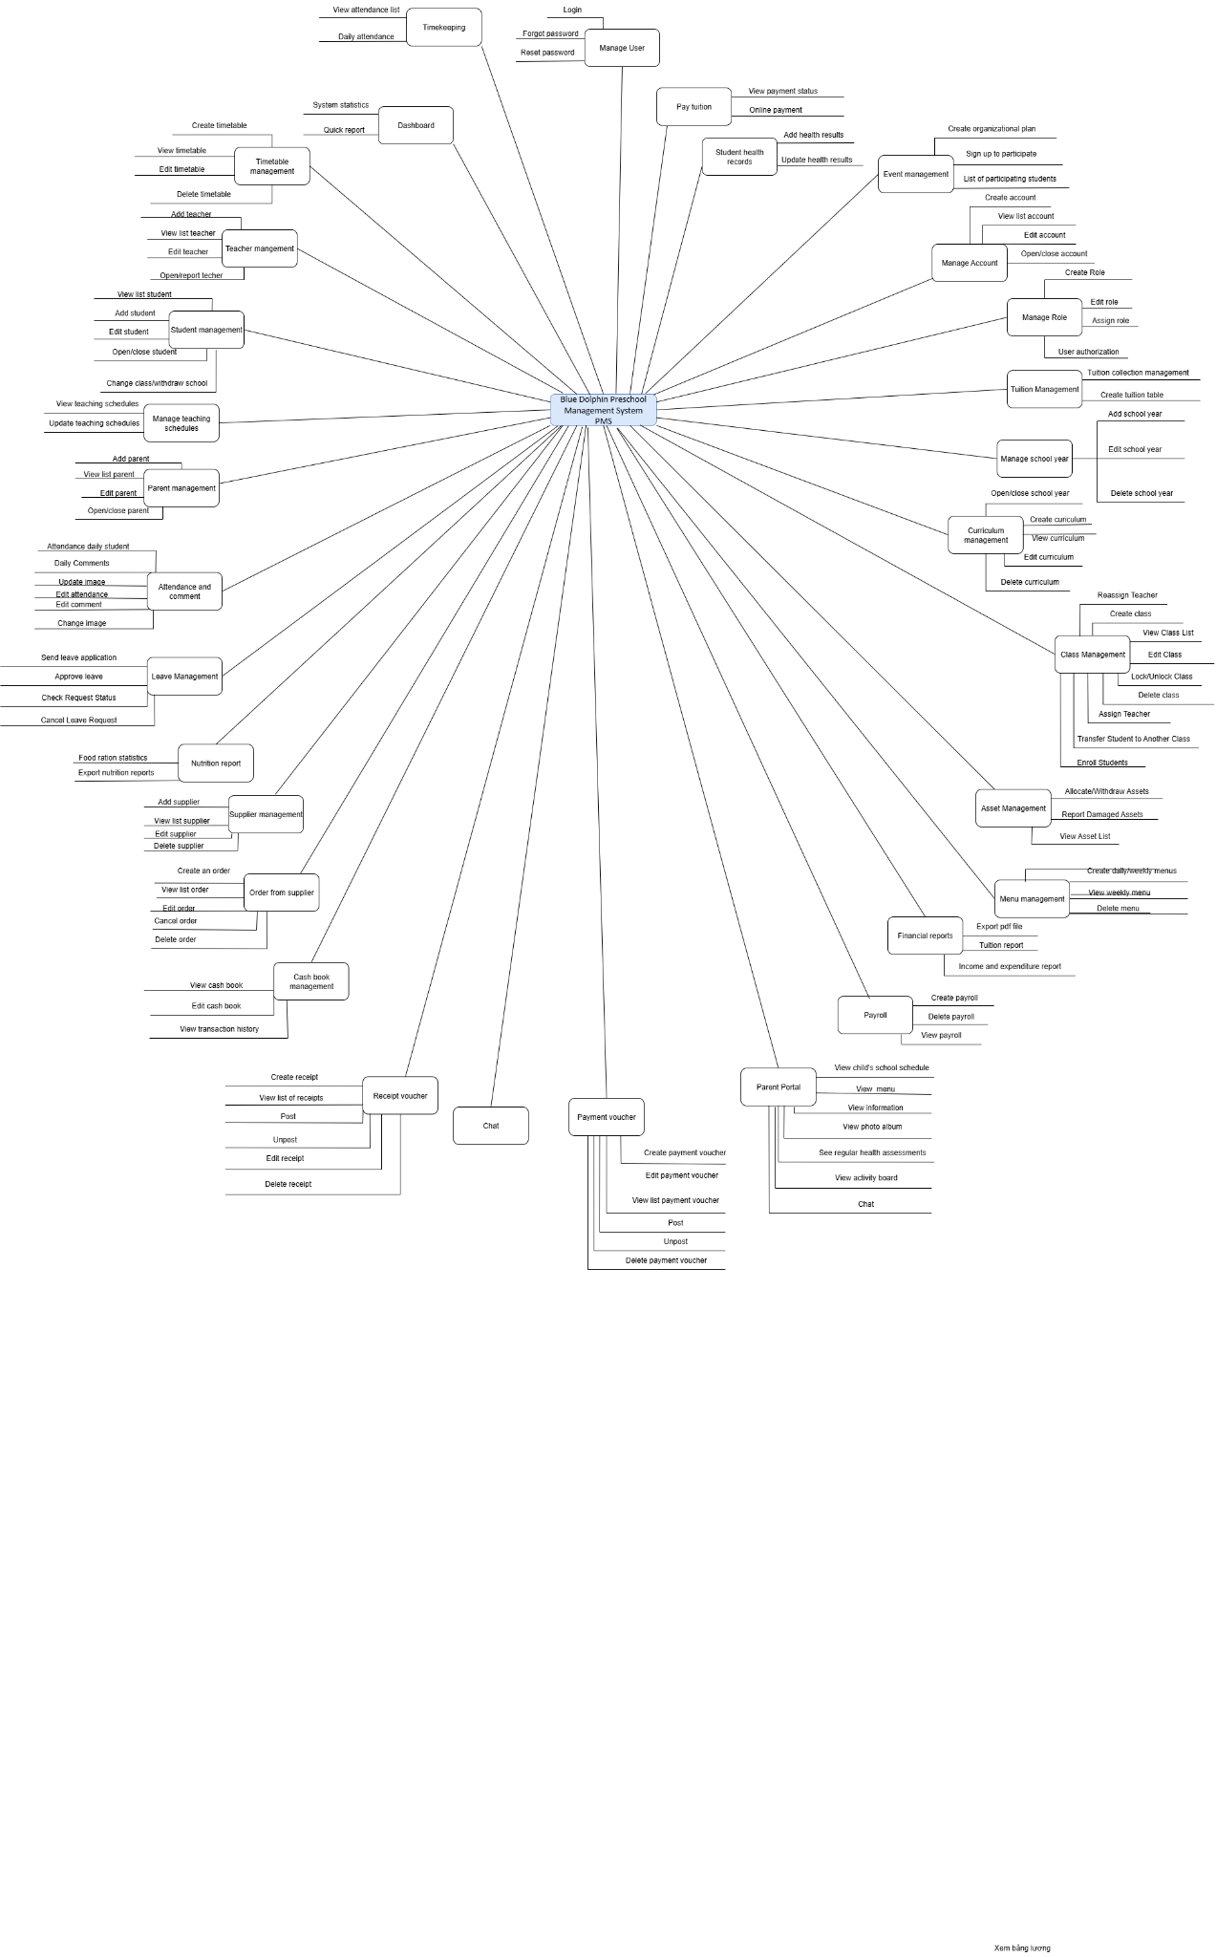

| **Feature ID** | **Feature description** |
| --- | --- |
| FE-01 | Manage Account : Allows administrators to create, update, assign roles, and delete user accounts. |
| FE-02 | Manage role : Enables administrators to create, edit, delete, and assign system roles to users for proper access control. |
| FE-03 | Tuition Management : Allows accountants to create and manage tuition structures, view tuition status, record payments, and report tuition. Parents can view and pay tuition online. |
| FE-04 | Manage school year: Enables administrators to create, edit, and delete school year details, manage active years. |
| FE-05 | Curriculum management : Supports view, creating, editing, and deleting curricula. |
| FE-06 | Class Management : Allows administrators and teachers to create, update, and delete classes; manage class lists, teacher assignments; and transfer students between classes. |
| FE-07 | Asset Management : Allows administrative staff to add, edit, and manage assets, report damaged assets, and track asset usage and availability. |
| FE-08 | Menu management: Allows administrative staff to create, update, and delete weekly or daily menus, and parents/teachers to view available meals. |
| FE-09 | Financial reports: Generate reports on tuition, income and expenses for accounting, providing detailed information about the school's finances. |
| FE-10 | Payroll: Allows accountants to create, update and manage payroll records, calculate salaries and generate payroll reports. |
| FE-11 | Parent Portal: Provides parents with access to their child’s timetable, attendance, announcements, photos, health records, and direct communication with teachers. |
| FE-12 | Payment voucher: Supports creating, editing, printing, and deleting payment vouchers to record school-related payments. |
| FE-13 | Chat: Enables real-time communication between parents, teacher through in-app messaging. |
| FE-14 | Receipt voucher: Allows staff to create, view, edit, print, and delete receipt vouchers for financial tracking. |
| FE-15 | Cash book management: Supports managing cash book entries, viewing transaction history, and editing cash book details. |
| FE-16 | Order from supplier: Allows administrative staff to create, edit, cancel and delete student meal orders. |
| FE-17 | Supplier management: Allows adding, editing, and deleting supplier information and viewing supplier lists. |
| FE-18 | Nutrition report: Generates nutrition-related reports, including student meal participation and nutritional balance of menus. |
| FE-19 | Leave Management: Enables staff to submit leave applications, track leave status, and allows administrators to approve or reject requests. |
| FE-20 | Attendance and comment: Supports recording daily attendance for students and teachers, generating attendance reports, and allowing comments or notes on attendance records. |
| FE-21 | Parent management: Allows administrators to add, update, and manage parent records, link them to student accounts, and monitor parent communication. |
| FE-22 | Manage teaching schedules: Allows teachers to create and update teaching schedules. |
| FE-23 | Student management: Supports adding, editing, and deleting student profiles, opening and closing students, and viewing student details. |
| FE-24 | Teacher management: Allows administrators to create, edit, and manage teacher profiles, track teacher information. |
| FE-25 | Timetable management: Enables administrators to create, edit, and view class timetables. |
| FE-26 | Dashboard: Provides an overview of key system statistics, including student attendance, financial data, schedules, and announcements. |
| FE-27 | Timekeeping: Allows recording and monitoring of staff working hours and attendance, generating timekeeping reports. |
| FE-28 | Manage User: Supports administrative tasks such as enabling/disabling accounts, resetting passwords. |
| FE-29 | Pay tuition: Enables parents to pay tuition fees securely online and view payment confirmation and status. |
| FE-30 | Student health records: Allows adding, updating, and viewing student health data, including medical checks and assessments. |
| FE-31 | Event management: Enables administrators to create and manage school events, register participants, and send notifications to parents and staff. |

### 6.2 Limitations & Exclusions

LI-1: Attendance Tracking Limitations: Currently, the system is unable to integrate with external attendance devices such as biometric scanners or RFID card readers. As a result, all attendance data must be entered manually by staff or recorded directly within the software. This can increase administrative workload and may lead to potential errors in attendance records if not carefully managed.

LI-2: Payroll Limitations: The payroll module in the system does not yet support comprehensive salary calculations. Specifically, it cannot automatically calculate additional components such as employee allowances, bonuses, or social insurance contributions. This means that payroll reports may be incomplete, and manual adjustments are required to reflect the full compensation for teachers and staff.

LI-3: General System Customization: The software provides standard templates and workflows for school management. However, it may not fully accommodate unique operational procedures or specific policies of individual schools. Customization options are limited, which can restrict flexibility in adapting the software to specialized needs.

LI-4: Data Integration: The system has limited ability to integrate with other external systems, such as government education reporting tools, third-party accounting software, or library and learning management systems. This could lead to duplicated data entry or inconsistencies if multiple platforms are used concurrently.

Internet and Hardware Dependence: As a web-based system, stable internet access and appropriate devices (computers, tablets, or smartphones) are required. In areas with unstable connectivity, the system’s performance may be hindered, affecting real-time data entry and reporting.